DS.140 Integration Design Specification



Item Management Application (Oracle Apex)

SCM_RICE_358

Author: Pranjul Garg

Creation Date: Jul 05, 2022

Last Updated: Jun 23, 2023

Version: 2.0

**Approvals:**

|  |  |
| --- | --- |
| <Approver 1> | <Rakesh Khanna / Naushad / Amit> |
| <Approver 2> | <Business Owner> |

# Document Control

## Change Record

| Date | Author | Version | Change Reference |
| --- | --- | --- | --- |
| 05-Jul-2022 | Pranjul Garg | 1.0 | No Previous Document |
| 23-Jun-2023 | Ajay Kumar | 2.0 | Addition of Chronic ailment, Low margin brand and Priority fields |
|  |  |  |  |
|  |  |  |  |

2

## Reviewers

| Name | Position |
| --- | --- |
| FHL Business | Business User |
| FHL IT Group | Fortis IT Team |
|  |  |
|  |  |

Contents

1 Document Control ii

1.1 Change Record ii

1.2 Reviewers ii

2 Introduction 4

2.1.1 Scope for this Document 4

2.1.2 Intended Audience 4

3 Overview 5

3.1 Business Objectives 5

3.2 Major Features 5

3.3 Glossary 5

4 High-Level Fusion Integration flow 6

5 Technical Design Details 7

5.1 OIC Services 7

5.2 Oracle PaaS DBCS components 8

5.3 Oracle APEX – Item Management application 10

5.3.1 PAGE LAYOUT 11

1.1 Additional Extension Validations & Deriving Logics 33

5.4 Technical flow 35

6 Data FIELD Mapping 36

6.1 File format 36

6.2 Frequency 36

6.3 Security and Access 36

6.4 Apex application Authentication scheme 36

6.5 Apex application List of Values 37

6.6 Apex application – Approval Workflow Specification 38

7 Exception handling 41

7.1 Scenarios 41

8 Assumptions / Considerations 42

9 Open and Closed Issues 43

9.1 Open Issues 43

9.2 Closed Issues 43

# Introduction

### Scope for this Document

This analysis specification document is prepared to layout the Item management Apex based application.

### Intended Audience

This document is intended for the following groups to provide the action items and consideration that are required to complete the implementation of the various Supply Chain and Finance related functionalities from Oracle Fusion.

#### Fortis Business Users

This document will be helpful for Fortis Business users to understand the technical design and process change with the new structure implemented in Oracle. The business user will validate this document after the verification of the requirement.

#### PwC Technical Team

The PwC technical team will use this document as a source technical design document to develop the technical solution to implement / deploy in Oracle Fusion.

#### Fortis IT Team

The Fortis IT Team must facilitate the PwC technical team for requisite details and other elements required from Business. The Fortis IT team is also responsible to arrange and provide required technical information wherever is required.

# Overview

Fortis Healthcare Limited (FHL) is a chain of hospitals, headquartered in India. Fortis started its health care operations from Mohali where first Fortis hospital was started. Later, the hospital chain purchased the healthcare branch of the Escorts group and increased its strength in various parts of the country. The Fortis health care also operates its hospital in Vasant Kunj, Faridabad, Gurgaon. The FMRI hospital at Gurgaon is the headquarter of Fortis healthcare with all the major facilities at the hospital.

This specification document is prepared to layout the design of the Item management Apex based application.

## Business Objectives

The following are the business objectives.

1. To have a secure, reliable, and scalable design flow to validate and interface item updates to Oracle fusion.
2. To have a solution providing the monitoring capabilities.

## Major Features

The proposed solution will have the following features involved:

1. The Item management application has been designed in Oracle APEX.
2. It also uses Apex BPM plugin to design the custom workflow approval process.
3. Multiple OIC integrations are involved for the various functionalities.

## Glossary

REST

Representational State Transfer.

OIC

Oracle Integration Cloud

# High-Level Fusion Integration flow

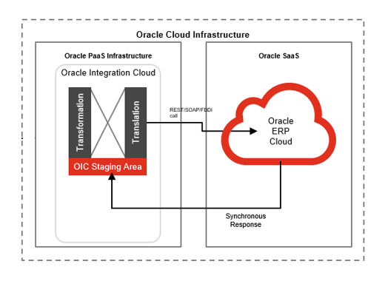

# Technical Design Details

This section describes the technical details of all the components involved in the Item management Apex based application.

## OIC Services

Following scheduled orchestration has been designed in OIC to invoke couple of PaaS DB procedure at the regular intervals to interface the Fusion Change Order details, process and trigger the custom workflows in Oracle APEX for NIR, Item Attribute update & Item price update requests:

|  |  |
| --- | --- |
| **OIC Integration Name** | Fortis Trigger NIR Integration |
| **OIC REST Endpoint URL** | NA |
| **Method** | NA |
| **Frequency** | Every 10 minutes |

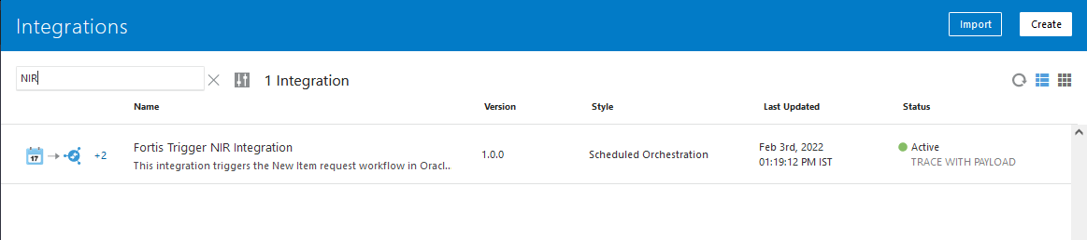

Following App driven orchestration is invoked from the above integration internally to sync the Item attachments from Oracle Fusion to PaaS DB to show them within the Item management application:

|  |  |
| --- | --- |
| **OIC Integration Name** | Fortis Sync Item Attachments Integration |
| **OIC REST Endpoint URL** | <https://oic-prod-nr5lr39yailj-bo.integration.ocp.oraclecloud.com:443/ic/api/integration/v1/flows/rest/FORTIS_SYNC_ITEM_ATTACH_INTG/1.0/callOIC/syncItemAttachments/> |
| **Method** | POST |

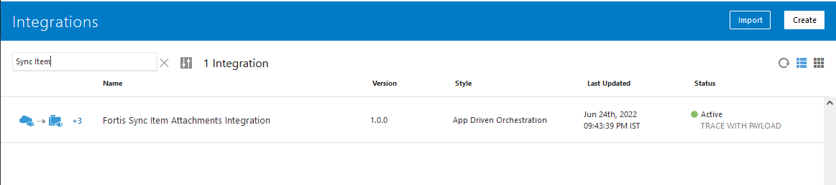

Following set of integrations are designed to update the correct Item category on the Item creation & Item update business events.

“Fortis Update Item Category Integration” is an app driven orchestration, which is being invoked from PaaS DB whenever there is an Item attribute update request by passing the given Item number & Organization to update the correct category under “FORTIS_ITEM_CATALOG”.

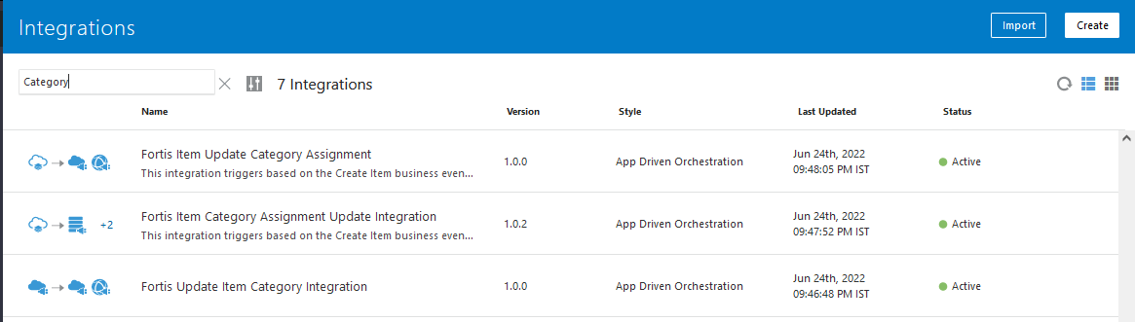

Following app driven orchestration is being run by the common integration (Fortis Trigger 60m Integration) to check such Items which have been assigned to a given DTH or OP Pharma organizations, but it’s not assigned to the Validation organization of the same BU.

It fetches such Item details from Fusion and assigns them into Validation organization.

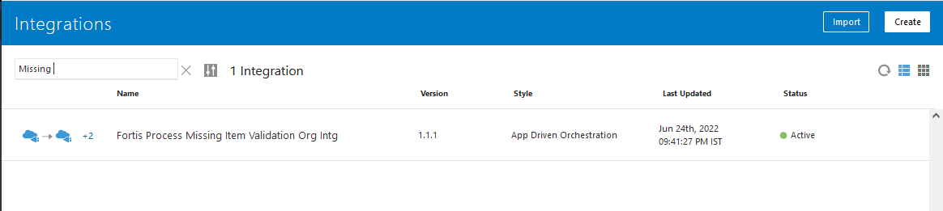

## Oracle PaaS DBCS components

This integration design uses the following components from Oracle PaaS DBCS:

|  |  |  |
| --- | --- | --- |
| **DB Component** | **Component name** | **Details** |
| **Tables** | XXFH_EGP_SYSTEM_ITEMS_B  XXFH_EGO_ITEM_EFF_B | These tables are the replica of Oracle fusion tables: EGP_SYSTEM_ITEMS_B & EGO_ITEM_EFF_B to show the item data in Item management application. |
| XXFH_ITEM_STATUS_DETAILS_ | This table stores the status for an Item whenever it is updated within Item management application. Once the item update request is completed, then the record is deleted from this table, and then the actual approval_status from XXFH_EGP_SYSTEM_ITEMS_B is shown in the Item management application. |
| XXFH_ITEM_ATTR_UPD_CP_PH_  XXFH_ITEM_ATTR_UPD_CP_MC_  XXFH_ITEM_ATTR_UPD_CP_NM_  XXFH_ITEM_ATTR_UPD_CP_SV_ | These tables are for the Central Parameter section for PH/MC/NM & SV item classes. |
| XXFH_ITEM_ATTR_UPD_UP_PH  XXFH_ITEM_ATTR_UPD_UP_MC  XXFH_ITEM_ATTR_UPD_UP_NM  XXFH_ITEM_ATTR_UPD_UP_SV | These tables are for the Unit Parameter section for PH/MC/NM & SV item classes. |
| XXFH_ITEM_ATTR_UPD_TA_ | This table is used for Tax Attribute section in Item management application |
| XXFH_ITEM_ATTR_UPD_PA_ | This table is used for Pricing Attribute section in Item management application |
| XXFH_ITEM_ATTR_UPD_PLA_ | This table is used for Planning Attribute section in Item management application |
| XXFH_ITEM_ATTR_UPD_DETAILS | This table holds the Fusion field level details for a given Item-org which have been updated by the user from Item Management application for Item attribute update page. |
| XXFH_ITEM_PRICE_DTLS_ | This table holds the data for item for Item price update request. |
| XXFH_ITEM_ATTACHMENTS_TBL | This table holds the item attachment data which are attached in Oracle Fusion and interfaced in PaaS DB to show them in Item Management application. |
| XXFH_ITEM_APPROVAL_DETAILS_TBL | This is the master table for Item approval workflow requests. |
| XXFH_ITEM_LOG_TBL | This is the log table for Item management application which holds the complete logging of every functionality. |
| XXFH_ITEM_MIN_MAX_QTY_TBL | This table holds the fields for Min-Max planning section in Item attribute update page in Item Management application |
| XXFH_ITEM_ORDER_QTY_TBL | This table holds the fields for Order section in Item attribute update page in Item Management application |
| **DB Directory** | xxfh_item_attachment_dir | This DB directory is used to load & access the Item attachment |
| **Function** | XXFH_ITEM_APP_READ_ONLY_FN | This function is used in every page of Item management application to derive if the current logged in person has access for the current page or the given section. |
| **Package** | XXFH_ITEM_APPROVAL_PKG | This is the master package which contains the entire logic for Item management application. |

## Oracle APEX – Item Management application

This application consists of the following pages mainly:

| S. No | Page Title | Description / Function | Key Features |
| --- | --- | --- | --- |
| 1 | Item Search | Allows the users to search for items and view their availability in different IOs. | * Displays one row for each item’s assignment in an IO. * Item search parameters to include standard item fields as well as EFF fields as per PDH. * Based on item search results, actions to be taken on the items found or new item creation will be displayed on the same item search page. * Operations will be allowed only on one item in the search results at a time. * Operations available for a user to perform on an item assigned to an IO other than FMO in the search results: item attribute update, item price update. * Operations available for a user to perform on an item assigned to FMO org: item assignment. |
| 2 | Item Update | Allows the users to update the item inventory attributes for a given IO assignment of the item. | * No. of fields available for update will be dependent on the user role assignment from security configurations in Oracle Cloud. * Based on item validations and transformation logics, incorrect data entered by the user will be displayed as an error message to the user post submitting the item update request. * Message for successful submission of the item update request will be displayed to the user. |
| 3 | Item assignment (includes attribute updates) | Allows the users to assign an item to another IO. | * No. of fields available for update will be dependent on the user role assignment from security configurations in Oracle Cloud. * Based on item validations and transformation logics, incorrect data entered by the user will be displayed as an error message to the user post submitting the item update request. * No. of IOs available for the user to assign an item will be available based on the access given to the user at item class security level. |
| 4 | Item price update | Allows the users to change the item price in an assigned org. | * Item price update will be available based on the price controls on the item (CBU/non-CBU). * Item price update will be done at the item org level or central level (propagated to all the assigned orgs). |

### PAGE LAYOUT

* Following is the Home page which is “Item Search Page” to search for any item which exists in Oracle Fusion. This page has 7 fields based on which user can search for a given Item. Each of the text fields supports partial search here which allows user to search for a given Item based on partial information he/she has.
* This same page also has a section for “Approval History” which shows the history of item approvals which has been submitted for approval by the current logged in user in the descending order. In Approval history section there is a link provided to see the details of action taken on any request for item.

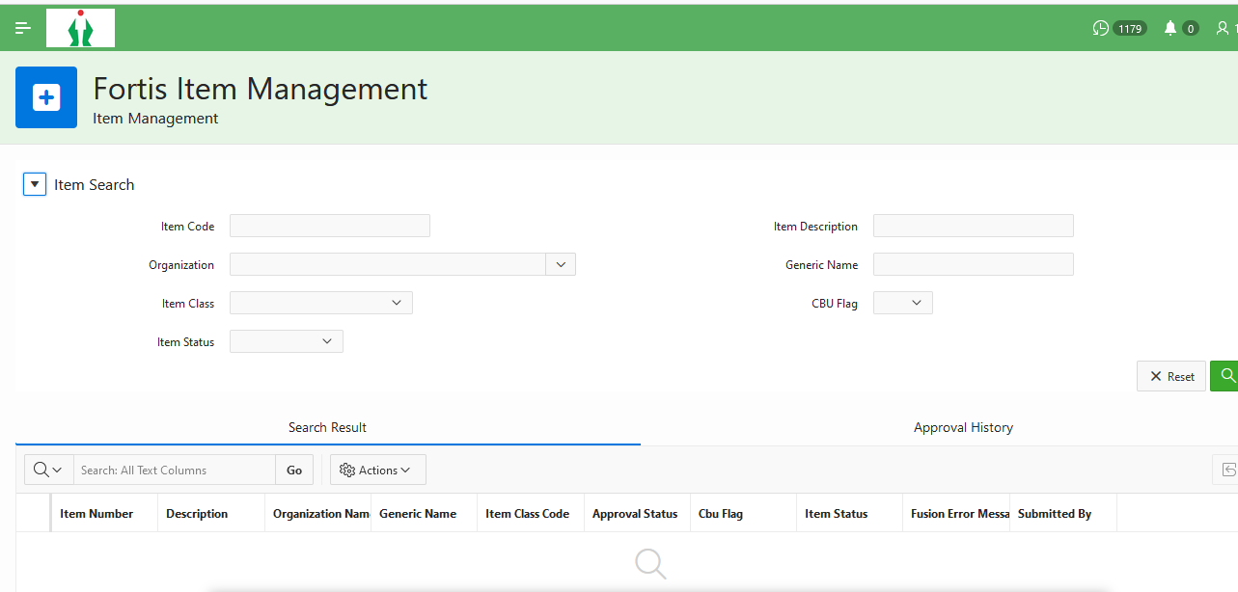

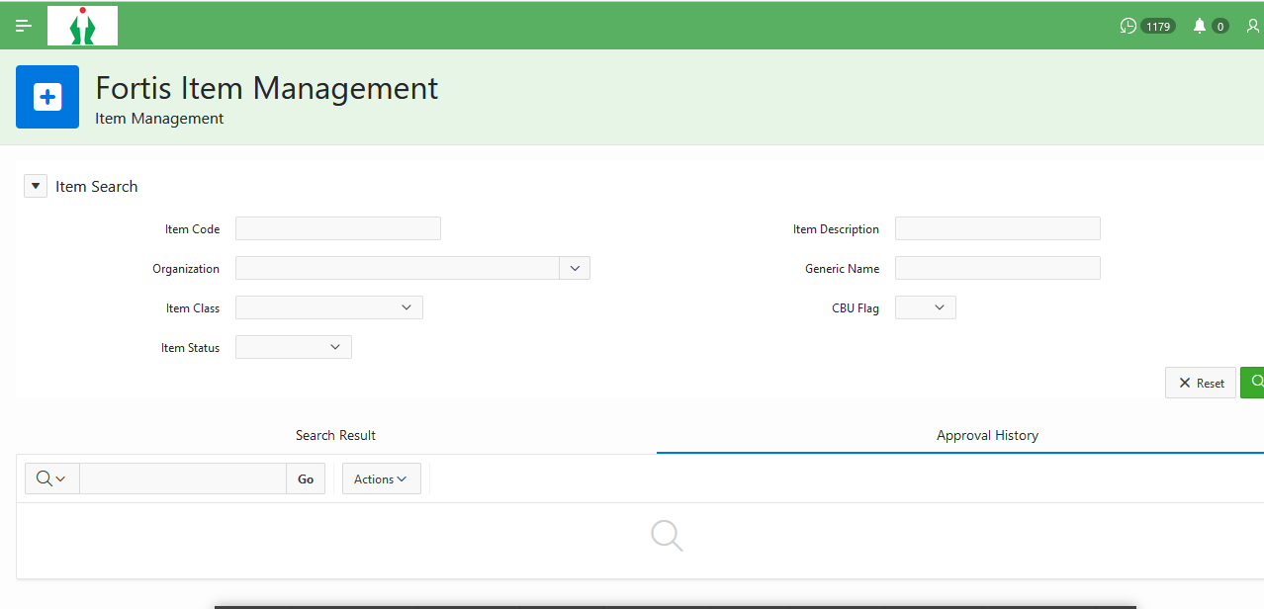

| Page Field / Button Name | Field / Button | Page Name | Page Section | Mandatory? | Field / Button Derivation Logic | Placement & Comments |
| --- | --- | --- | --- | --- | --- | --- |
| Item Code | Field | Item Search | Search Parameters | No | Item number.  Field should be a dynamic LOV- as the user searches for an item, possible suggestions for the item must be displayed in an LOV. |  |
| Item Description | Field | Item Search | Search Parameters | Yes | Item Description  Field should be a dynamic LOV- as the user searches for an item description, possible suggestions for the item must be displayed in an LOV. |  |
| Organization | Field | Item Search | Search Parameters | Yes | Inventory Org to which the item is assigned.  Field should be a dynamic LOV- as the user searches for an IO, possible suggestions for the item must be displayed in an LOV. |  |
| Generic Name | Field | Item Search | Search Parameters | No | Generic Name of the item mentioned in the item EFF attributes.  Field should be a dynamic LOV- as the user searches for a generic name, possible suggestions for the item must be displayed in an LOV. |  |
| Search | Button | Item Search | Search Parameters | N/A | By clicking on Search, the extension should search for the item(s) with matching search parameters. |  |
| Reset | Button | Item Search | Search Parameters | N/A | Upon clicking reset, the values entered in the search parameters should be removed and the search parameters pane should be empty. |  |
| Action (Select drop-down) | Button | Item Search | Search Results | N/A | * For each item result, the user will get an option to either update the price or update the item attributes (other than price). * Item Assignment option in the Select Action dropdown must appear only if the assigned org of the item in search result is FMO. | In each row, under the first column of Search Results table. |
| Item Number | Field | Item Search | Search Results | N/A |  |  |
| Item Description | Field | Item Search | Search Results | N/A |  |  |
| Assigned Org | Field | Item Search | Search Results | N/A |  |  |
| GenericName | Field | Item Search | Search Results | N/A |  |  |

* Following is the “Item Attribute Page”, which is used to show all the Item attributes (defined as EFFs in Oracle Fusion) and update them as per the business logics. This page has header, Central Parameter, Unit Parameter, Tax Attributes, Pricing Attributes, Planning Attributes, Min-Max Planning & Order Quantity sections.
* All these sections are collapsible in nature which provides user a flexibility to collapse & expand as per his convenience to see through the page in a better way.

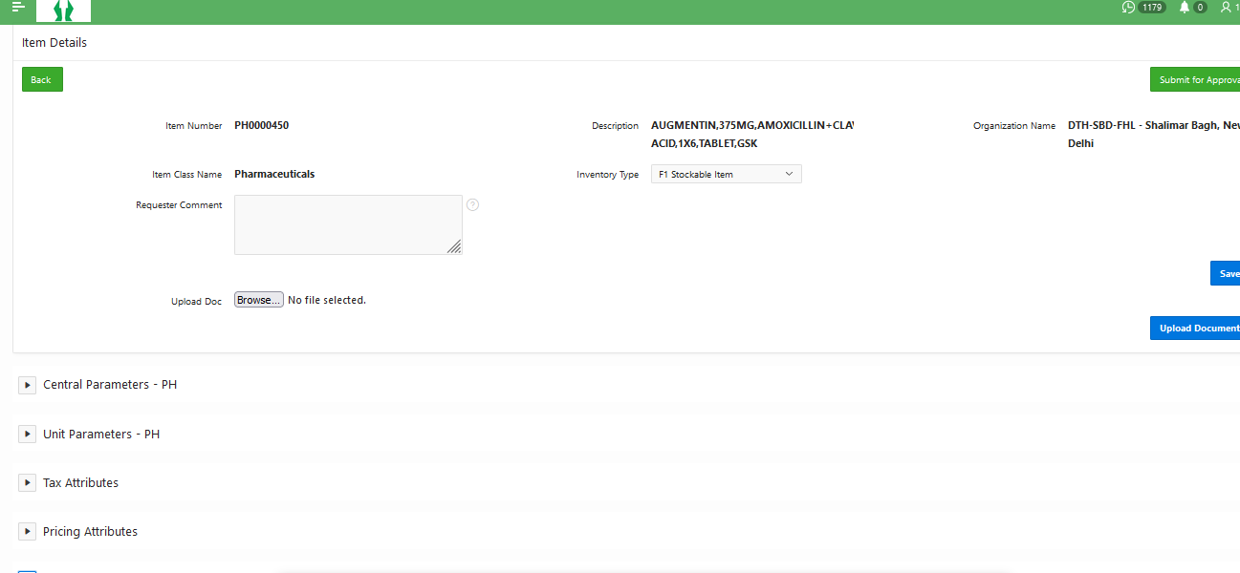

| Page Field / Button Name | Field / Button | Page Name | Page Section | Mandatory? | Field Type | Field / Button Derivation Logic | Remarks |
| --- | --- | --- | --- | --- | --- | --- | --- |
| Item Code | Field | Item Attribute Update | Header | No | LOV | Item number. Read-only field. |  |
| Item Description | Field | Item Search | Search Parameters | No | Text | Item Description. Read-only field. |  |
| Org | Field | Item Attribute Update | Header | No | LOV | Organization assignment of the item opened for update. Read-only field. |  |
| Item Class | Field | Item Attribute Update | Header | No | LOV | Item Class name of the item opened for update. Read-only field. |  |
| Inventory Type | Field | Item Attribute Update | Header | Yes (for PH / MC / NM items) | LOV | User Item Type on the item. Can be updated by the user while updating the item attributes in an IO.   * If the Inventory type field is updated by the user for an item, the corresponding change will be interfaced to the User Item Type field on the item in PDH. * Inventory type field will be used to derive the segment 8 of item category segments. Mapping between the inventory type values and segment 8 will be maintained in the Lookup Code & description columns of the lookup EGP_ITEM_TYPE. |  |
| Brand Name | Field | Item Attribute Update | Central Parameters | Yes | LOV | * Only available for items having item class as “Pharmaceuticals”. * Field update allowed only when the org assignment of the item is FMO. * Values should be derived from the Brand Name value set- XXFH_BRAND_NAME_PH |  |
| Strength | Field | Item Attribute Update | Central Parameters | Yes | LOV | * Only available for items having item class as “Pharmaceuticals”. * Field update allowed only when the org assignment of the item is FMO. * Values should be derived from the Strength Name value set- XXFH_STRENGTH_PH |  |
| Generic | Field | Item Attribute Update | Central Parameters | Yes | LOV | * Only available for items having item class as “Pharmaceuticals”. * Field update allowed only when the org assignment of the item is FMO. * Values should be derived from the Generic value set- XXFH_GENERIC_PH |  |
| Packing | Field | Item Attribute Update | Central Parameters | Yes | LOV | * Only available for items having item class as “Pharmaceuticals”. * Field update allowed only when the org assignment of the item is FMO. * Values should be derived from the Packing value set- XXFH_PACKING_PH |  |
| Drug Form | Field | Item Attribute Update | Central Parameters | Yes | LOV | * Only available for items having item class as “Pharmaceuticals”. * Field update allowed only when the org assignment of the item is FMO. * Values should be derived from the Drug Form value set- XXFH_DRUG_FORM_PH |  |
| Manufacturer | Field | Item Attribute Update | Central Parameters | Yes | LOV | * Field visibility allowed for PH & MC item class. * Field update allowed only when the org assignment of the item is FMO. * Values should be derived from the Manufacturer Name value set- XXFH_MANUFACTURER |  |
| Narcotic Item | Field | Item Attribute Update | Central Parameters | Yes | LOV | * Field visibility allowed for PH & MC item class. * Field update not allowed as it is dependent on the selection of Generic field. * Value to be defaulted from the selection of Generic master. If the Generic master value is changed in the item attribute update, then the field value should be automatically updated. |  |
| High Risk | Field | Item Attribute Update | Central Parameters | Yes | LOV | * Field visibility allowed for PH & MC item class. * Field update not allowed as it is dependent on the selection of Generic field. * Value to be defaulted from the selection of Generic master. If the Generic master value is changed in the item attribute update, then the field value should be automatically updated. |  |
| Restricted Antibiotics | Field | Item Attribute Update | Central Parameters | Yes | LOV | * Field visibility allowed for PH & MC item class. * Field update not allowed as it is dependent on the selection of Generic field. * Value to be defaulted from the selection of Generic master. If the Generic master value is changed in the item attribute update, then the field value should be automatically updated. |  |
| Schedule Master | Field | Item Attribute Update | Central Parameters | Yes | LOV | * Field visibility allowed for PH & MC item class. * Field update not allowed as it is dependent on the selection of Generic field. * Value to be defaulted from the selection of Generic master. If the Generic master value is changed in the item attribute update, then the field value should be automatically updated. |  |
| Generic Code | Field | Item Attribute Update | Central Parameters | Yes | LOV | * Field visibility allowed for PH & MC item class. * Field update not allowed as it is dependent on the selection of Generic field. * Value to be defaulted from the selection of Generic master. If the Generic master value is changed in the item attribute update, then the field value should be automatically updated. |  |
| Class Code | Field | Item Attribute Update | Central Parameters | Yes | LOV | * Field visibility allowed for PH & MC item class. * Field update not allowed as it is dependent on the selection of Generic field. * Value to be defaulted from the selection of Generic master. If the Generic master value is changed in the item attribute update, then the field value should be automatically updated. |  |
| CIMS Code | Field | Item Attribute Update | Central Parameters | Yes | LOV | * Field visibility allowed for PH & MC item class. * Field update allowed only when the org assignment of the item is FMO. * Field values to be derived from a value set XXFH_CIMS_CODE. |  |
| Cold Chain | Field | Item Attribute Update | Central Parameters | Yes | LOV | * Field visibility allowed for PH & MC item class. * Field update not allowed as it is dependent on the selection of Generic, Strength & Drug Form fields. * For PH items, value of Cold Chain to be defaulted from the Inventory Generic Master by referencing the generic, strength and drug form fields * For MC items, value of Cold Chain to be defaulted from the Inventory Generic Master by referencing the item category combination. |  |
| Common Name | Field | Item Attribute Update | Central Parameters | Yes | Text | * To be displayed only for MC item class. * Field update allowed only when the org assignment of the item is FMO. * Free text field with character limit of 30 chars. |  |
| Dimensions | Field | Item Attribute Update | Central Parameters | Yes | Text | * To be displayed only for MC item class. * Field update allowed only when the org assignment of the item is FMO. * Free text field with character limit of 30 chars. |  |
| Material | Field | Item Attribute Update | Central Parameters | Yes | Text | * To be displayed only for MC item class. * Field update allowed only when the org assignment of the item is FMO. * Free text field with character limit of 30 chars. |  |
| Manufacturer Ref. of PD Code | Field | Item Attribute Update | Central Parameters | Yes | Text | * To be displayed only for MC item class. * Field update allowed only when the org assignment of the item is FMO. * Free text field with character limit of 30 chars. |  |
| Formulary | Field | Item Attribute Update | Central Parameters | No | LOV | * To be displayed for PH/MC items only. * Field update allowed only when the org assignment of the item is FMO. * Values to be taken from Formulary lookup in PDH. |  |
| Specialty | Field | Item Attribute Update | Central Parameters | Yes | LOV | * To be displayed for all item classes. * Values to be displayed differently for each item class. * Field update allowed only when the org assignment of the item is FMO. * Specialty values are maintained in the respective specialty value sets in PDH, namely XXFH_SPECIALTY_PH, XXFH_SPECIALTY_MC, XXFH_SPECIALTY_NM, XXFH_SPECIALTY_SV, XXFH_SPECIALTY_CA. |  |
| Product Type | Field | Item Attribute Update | Central Parameters | Yes | LOV | * To be displayed for all item classes. * Values to be displayed differently for each item class. * Field update allowed only when the org assignment of the item is FMO. * PRODUCT_TYPE values are maintained in the respective PRODUCT_TYPE value sets in PDH, namely XXFH_PRODUCT_TYPE_PH, XXFH_PRODUCT_TYPE_MC, XXFH_PRODUCT_TYPE_NM, XXFH_PRODUCT_TYPE_SV, XXFH_PRODUCT_TYPE_CA. |  |
| Category 4 | Field | Item Attribute Update | Central Parameters | Yes | LOV | * To be displayed for all item classes. * Values to be displayed differently for each item class. * Field update allowed only when the org assignment of the item is FMO. * CATEGORY_4 values are maintained in the respective CATEGORY_4 value sets in PDH, namely XXFH_CATEGORY_4_PH, XXFH_CATEGORY_4_MC, XXFH_CATEGORY_4_NM, XXFH_CATEGORY_4_SV, XXFH_CATEGORY_4_CA. |  |
| Category 5 | Field | Item Attribute Update | Central Parameters | Yes | LOV | * To be displayed for all item classes. * Values to be displayed differently for each item class. * Field update allowed only when the org assignment of the item is FMO. * CATEGORY_ values are maintained in the respective CATEGORY_ value sets in PDH, namely XXFH_CATEGORY__PH, XXFH_CATEGORY__MC, XXFH_CATEGORY__NM, XXFH_CATEGORY__SV, XXFH_CATEGORY__CA. |  |
| Category 6 | Field | Item Attribute Update | Central Parameters | Yes | LOV | * To be displayed for all item classes. * Values to be displayed differently for each item class. * Field update allowed only when the org assignment of the item is FMO. * CATEGORY_6 values are maintained in the respective CATEGORY_6 value sets in PDH, namely XXFH_CATEGORY_6_PH, XXFH_CATEGORY_6_MC, XXFH_CATEGORY_6_NM, XXFH_CATEGORY_6_SV, XXFH_CATEGORY_6_CA. |  |
| Category 7 | Field | Item Attribute Update | Central Parameters | Yes | LOV | * To be displayed for all item classes. * Values to be displayed differently for each item class. * Field update allowed only when the org assignment of the item is FMO. * CATEGORY_7 values are maintained in the respective CATEGORY_7 value sets in PDH, namely XXFH_CATEGORY_7_PH, XXFH_CATEGORY_7_MC, XXFH_CATEGORY_7_NM, XXFH_CATEGORY_7_SV, XXFH_CATEGORY_7_CA. |  |
| Category 8 | Field | Item Attribute Update | Central Parameters | Yes | LOV | * To be displayed for all item classes. * Editing of this field will not be allowed. * Values to be defaulted based on the selection of inventory type field. * Item category of the item should be updated at the assigned org level if the org assigned on the item is not FMO. If the org is FMO, then the item category update should be propagated to all the assigned orgs. * Corresponding to the change in category 8, the item category of the item should be changed at the item org level. * Mapping between the inventory type values and segment 8 will be maintained in the Lookup Code & description columns of the lookup EGP_ITEM_TYPE. |  |
| CBU Negotiable | Field | Item Attribute Update | Central Parameters | Yes | LOV | * To be displayed for all item classes. * Access to change must be restricted with the CBU team users. * Values available- Yes/No. |  |
| DPCO | Field | Item Attribute Update | Central Parameters | Yes | LOV | * To be displayed only for PH & MC item classes. * Values available- Yes/No. * Editing of this field to be allowed only when the Generic value selected for the item does not have a corresponding record in the Inventory Generic Master. * Field update not allowed when a combination of Generic, Strength & Drug Form fields is found in the inventory generic master. Field update will be allowed if this combination is not found in the inventory generic master. * For PH items, value of DPCO to be defaulted from the Inventory Generic Master by referencing the generic, strength and drug form fields * For MC items, value of DPCO to be defaulted from the Inventory Generic Master by referencing the item category combination. |  |
| DPCO Ceiling Price | Field | Item Attribute Update | Central Parameters | Yes, if DPCO is Yes | Numeric Text | * To be displayed only for PH & MC item classes. * Editing of this field to be allowed only when the Generic value selected for the item does not have a corresponding record in the Inventory Generic Master. * Field update not allowed when a combination of Generic, Strength & Drug Form fields is found in the inventory generic master. Field update will be allowed if this combination is not found in the inventory generic master. * For PH items, value of DPCO to be defaulted from the Inventory Generic Master by referencing the generic, strength and drug form fields * For MC items, value of DPCO to be defaulted from the Inventory Generic Master by referencing the item category combination. |  |
| DPCO First Notification Date | Field | Item Attribute Update | Central Parameters | Yes, if DPCO is Yes | Date | * To be displayed only for PH & MC item classes. * Only date values to be allowed. * Editing of this field to be allowed only when the Generic value selected for the item does not have a corresponding record in the Inventory Generic Master. * Field update not allowed when a combination of Generic, Strength & Drug Form fields is found in the inventory generic master. Field update will be allowed if this combination is not found in the inventory generic master. * For PH items, value of DPCO to be defaulted from the Inventory Generic Master by referencing the generic, strength and drug form fields * For MC items, value of DPCO to be defaulted from the Inventory Generic Master by referencing the item category combination. |  |
| DPCO Latest Notification Date | Field | Item Attribute Update | Central Parameters | Yes, if DPCO is Yes | Date | * To be displayed only for PH & MC item classes. * Only date values to be allowed. * Editing of this field to be allowed only when the Generic value selected for the item does not have a corresponding record in the Inventory Generic Master. * Field update not allowed when a combination of Generic, Strength & Drug Form fields is found in the inventory generic master. Field update will be allowed if this combination is not found in the inventory generic master. * For PH items, value of DPCO to be defaulted from the Inventory Generic Master by referencing the generic, strength and drug form fields * For MC items, value of DPCO to be defaulted from the Inventory Generic Master by referencing the item category combination. |  |
| Usability Type | Field | Item Attribute Update | Central Parameters | Yes | LOV | * To be displayed only for PH & MC item classes. * Possible values- V, E, D. To be taken from the value set XXFH_USABILITY_FLAG in PDH. * Field should be editable only if there is no corresponding value in the Generic master for a Generic code provided on the item. * If there is a Usability type value available on the Generic master for the selection of Generic code on the item, then the value should default on the item and the field should be non-editable. |  |
| Chronic Ailment Changes | Field | Item Attribute Update | Central Parameters | Yes | LOV | * To be displayed for PH/MC item classes. * Values available- Yes/No. |  |
| Low Margin Brands | Field | Item Attribute Update | Central Parameters | Yes | LOV | * To be displayed for PH/MC item classes. * Values available- Yes/No. |  |
| Default Receiving Store | Field | Item Attribute Update | Unit Parameters | Yes | LOV | * Field will be available for all item types. * Should contain values for all the active sub inventories available in the IO for which the item is updated. * Upon selection of the default receiving store, the PaaS extension must create an entry in the Setup & Maintenance task “Manage Inventory Transaction Defaults” for the given item, IO & sub inventory combination to make the sub-inv default at receiving the item. |  |
| Expense Account | Field | Item Attribute Update | Unit Parameters | Yes | LOV | Requirement for this field is yet to be confirmed since for all purchasing purposes, the expense account will be picked from TAB rules. |  |
| Inventory Planning Method | Field | Item Attribute Update | Planning Attributes | Yes, if inventory type is ROL | LOV | * To be only visible for PH, MC, NM (only for inventory type as “Inventory Expense”) item classes when the ROL Inventory type is selected. * Single default value to be shown- Reorder point planning. |  |
| Is Batched | Field | Item Attribute Update | Central Parameters | Yes | LOV | * To be displayed for all item classes. * LOV values- Yes/No * To be defaulted as Yes for PH/MC item classes items. * Editing of this field is not allowed during item update. |  |
| Primary UOM | Field | Item Attribute Update | Central Parameters | Yes | LOV | * To be displayed for all item classes. * Editing of this field is not allowed. |  |
| Secondary UOM | Field | Item Attribute Update | Central Parameters | Yes | LOV | * To be displayed only for PH & MC item classes. * Editing of this field is allowed only if the item org is FMO. |  |
| List Price | Field | Item Attribute Update | Pricing Attributes | Yes | Numeric text | * To be displayed for all item classes. * Editing of this field is not allowed for item attribute update. * Value of the list price will change based on change in CBU controlled item attributes, namely- Pricing based on % of MRP, Manufacturer discount. * If the value of list price is changed based on the selection of CBU controlled attributes, then the list price change should be propagated to all the orgs in which the item is assigned to. * Price precision of price will be kept to 2 decimal places. |  |
| Market Price | Field | Item Attribute Update | Pricing Attributes | Yes | Numeric text | * To be displayed for all item classes. * Editing of this field is not allowed for item attribute update. * Market Price should always be more than or equal to the list price. * Price precision of price will be kept to 2 decimal places. |  |
| Department Consumption Item | Field | Item Attribute Update | Unit Parameters | Yes | LOV | * Field to be shown for PH, MC, NM (only for inventory type as “Inventory Expense”) items only. * LOV values- Yes/No. |  |
| Row & Rack Number | Field | Item Attribute Update | Unit Parameters | Yes | Text | * Field to be shown for PH, MC, NM (only for inventory type as “Inventory Expense”) items only. * Free text field with max length of up to 150 characters. |  |
| HSN Code | Field | Item Attribute Update | Tax Attributes | Yes | LOV | * Field to be shown for all item classes. * Editing of this field is allowed only if the org of the item is FMO. * Values in the field to be derived from HSN master stored in the XXFH_HSN_CODE value set in PDH. |  |
| HSN Start Date | Field | Item Attribute Update | Tax Attributes | Yes | Date | * Field to be shown for all item classes. * Editing of this field is allowed only if the org of the item is FMO. |  |
| HSN End Date | Field | Item Attribute Update | Tax Attributes | No | Date | * Field to be shown for all item classes. * Editing of this field is allowed only if the org of the item is FMO. |  |
| Input Tax Classification Code | Field | Item Attribute Update | Tax Attributes | Yes | LOV | * Field to be shown for all item classes. * Editing of this field is not allowed. * Value of the field is dependent on the selection of HSN code. The value of this field on basis of HSN code can be derived from the value set XXFH_HSN_CODE. * Validation required to override the value of this field from a non-recoverable tax code to recoverable tax code if the item is assigned to OP pharmacy IO. * If the HSN code on the item is changed, corresponding change in the Input Tax Classification Code should be propagated to all the assigned orgs. Validation for transforming the tax code to recoverable for OP pharmacy IO assignment is required during propagation. |  |
| Pricing based on % of MRP | Field | Item Attribute Update | Pricing Attributes | Yes | LOV | * Field to be shown for all item classes. * Values allowed- Yes/No. * Editing of this field is allowed based on the CBU Negotiable flag value. * If the CBU negotiable flag is Yes, then this field should be editable only when the item org is FMO. The changed value of this field must be propagated to all the IO assignments of the item upon approval. * If the CBU negotiable flag is No, then this field can be edited at any org. Item assignment propagation is not required. |  |
| Percentage of MRP | Field | Item Attribute Update | Pricing Attributes | Yes, if Pricing based on % of MRP is yes | Numeric text | * Field to be shown for all item classes. * Values allowed between 0 and 100 (both exclusive) and up to 2 decimal places. * Editing of this field is allowed based on the CBU Negotiable flag value. * If the CBU negotiable flag is Yes, then this field should be editable only when the item org is FMO. The changed value of this field must be propagated to all the IO assignments of the item upon approval. * If the CBU negotiable flag is No, then this field can be edited at any org. Item assignment propagation is not required. |  |
| Manufacturer Discount | Field | Item Attribute Update | Pricing Attributes | No | Numeric text | * Field to be shown for all item classes. * Values allowed between 0 and 100 (both exclusive) and up to 2 decimal places. * Editing of this field is allowed based on the CBU Negotiable flag value. * If the CBU negotiable flag is Yes, then this field should be editable only when the item org is FMO. The changed value of this field must be propagated to all the IO assignments of the item upon approval. * If the CBU negotiable flag is No, then this field can be edited at any org. Item assignment propagation is not required. |  |
| Purchasable | Field | Item Attribute Update | Unit Parameters | Yes | LOV | * Field to be shown for all item classes. * Values allowed- Yes/No. * Editing of this field is allowed only if the org on the item opened for editing is FMO and the value of the flag is Yes. For a value of No, editing is allowed for all assigned items. * If the value of this flag is changed from Yes to No, then for all the orgs where the item is assigned to, the flag value must be changed to No. * If the value of this flag is changed from No to Yes, then it will be changed only in the org to which the item is assigned to. |  |
| Planner | Field | Item Attribute Update | Planning Attributes | Yes, if Inventory type is ROL | LOV | * Field to be shown for PH, MC, NM (only for inventory type as “Inventory Expense”) item classes. * Values allowed should be picked from the Planner codes defined in Oracle Cloud. * Editing allowed for Planner value both at FMO & IO levels. * If the planner value is edited at the FMO level, then it should be propagated to all the orgs to which the item is assigned. |  |
| Lead Time | Field | Item Attribute Update | Planning Attributes | Yes, if Inventory type is ROL | Numeric Text | * Field to be shown for PH, MC, NM (only for inventory type as “Inventory Expense”) item classes. * Values allowed should be dependent on the Planner codes defined in the previous field. * Editing not allowed for Lead Time field. * If the lead time value is changed at the FMO level, then it should be propagated to all the orgs to which the item is assigned. |  |
| Demand Fluctuation in Days | Field | Item Attribute Update | Planning Attributes | Yes, if Inventory type is ROL | Numeric Text | * Field to be shown for PH, MC, NM (only for inventory type as “Inventory Expense”) item classes. * Values allowed should be whole numbers from 0 to 100. * Editing allowed for field value both at FMO & IO levels. * If the field value is edited at the FMO level, then it should be propagated to all the orgs to which the item is assigned. |  |
| % Lead Time Fluctuation | Field | Item Attribute Update | Planning Attributes | Yes, if Inventory type is ROL | Numeric Text | * Field to be shown for PH, MC, NM (only for inventory type as “Inventory Expense”) item classes. * Values allowed should be whole numbers from 0 to 100. * Editing allowed for this field value both at FMO & IO levels. * If the field value is edited at the FMO level, then it should be propagated to all the orgs to which the item is assigned. |  |
| % Demand Fluctuation | Field | Item Attribute Update | Planning Attributes | Yes, if Inventory type is ROL | Numeric Text | * Field to be shown for PH, MC, NM (only for inventory type as “Inventory Expense”) item classes. * Values allowed should be whole numbers from 0 to 100. * Editing allowed for this field value both at FMO & IO levels. * If the field value is edited at the FMO level, then it should be propagated to all the orgs to which the item is assigned. |  |
| Fixed Lot Multiplier | Field | Item Attribute Update | Planning Attributes | Yes, if Inventory type is ROL | Numeric Text | * Field to be shown for PH, MC, NM (only for inventory type as “Inventory Expense”) item classes. * Values allowed should be in multiples of 5 from 5 to 100. * Editing allowed for this field value both at FMO & IO levels. * If the field value is edited at the FMO level, then it should be propagated to all the orgs to which the item is assigned. |  |
| Item Classification | Field | Item Attribute Update | Central Parameters | No | LOV | * Field to be shown for all item classes. * Field update will not be allowed. * Static values to be displayed. |  |
| Is Item Cleaned | Field | Item Attribute Update | Central Parameters | No | Check box | * Field to be shown for all item classes. * Field update allowed only at the FMO level. * Field update should be propagated to the assigned orgs of the item. |  |
| Main Group | Field | Item Attribute Update | Central Parameters |  | LOV |  |  |
| Sub Group | Field | Item Attribute Update | Central Parameters |  | LOV |  |  |
| Formulary percentage | Field | Item Attribute Update | Central Parameters |  | Text |  |  |
| Research | Field | Item Attribute Update | Central Parameters | No | LOV | * Field to be shown for PH, MC item classes. * Field update allowed only at the FMO level. * LOV values- Yes/No. * Field update should be propagated to the assigned orgs of the item. |  |
| Long Description | Field | Item Attribute Update | Header | Yes | Text | * Field to be shown for all item classes. * Field update allowed only at the FMO level. * Field update should be propagated to the assigned orgs of the item. |  |
| Attachments | Field | Item Attribute Update | Unit Parameters | No | File | * Field to upload attachments to be shown for all item classes. * Uploaded attachments to be kept at the item org level where they are uploaded. * Multiple attachments upload option to be provided. |  |
| Priority | Field | Item Attribute Update | Central Parameters | Yes | LOV | * Field to be shown for all item classes. * Used to decide the priority level of approvals. Available values- High, Medium, Low. * Value selected in priority should be captured in an item DFF, which will be used to set the priority of change order created. |  |
| Recommended & Authenticated By | Field | Item Attribute Update | Unit Parameters | Yes | Text | * Field to be shown for all item classes. * Used to specify the name of person recommending and authenticating the change. * Field length- 150 chars. |  |

* Following is the “Item Price update” page which is used to update List price or Market price for a given Item.

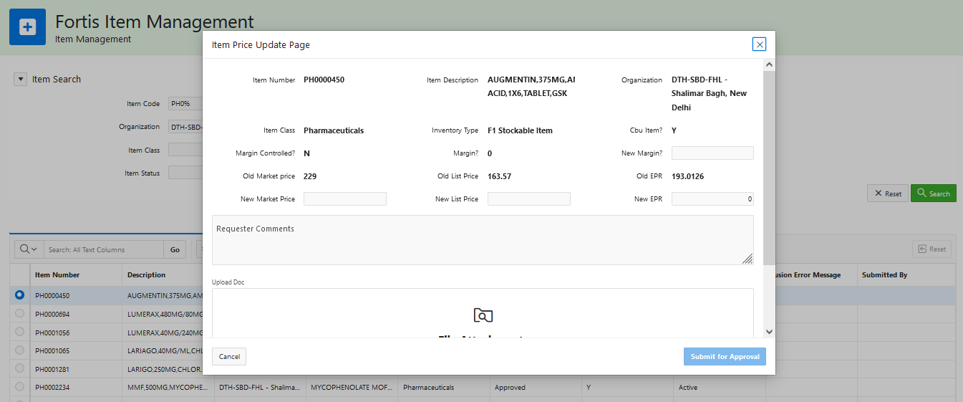

| Page Field / Button Name | Field / Button | Page Name | Page Section | Mandatory? | Field Type | Field / Button Derivation Logic | Remarks |
| --- | --- | --- | --- | --- | --- | --- | --- |
| Item Code | Field | Item Price Update | Header | No | LOV | Item number. Read-only field. |  |
| Item Description | Field | Item Price Update | Header | No | Text | Item Description. Read-only field. |  |
| Org | Field | Item Price Update | Header | No | LOV | Organization assignment of the item opened for update. Read-only field. |  |
| Item Class | Field | Item Price Update | Header | No | LOV | Item Class name of the item opened for update. Read-only field. |  |
| Inventory Type | Field | Item Price Update | Header | No | LOV | User Item Type on the item. Read-only field. |  |
| CBU Item? | Field | Item Price Update | Header | No | LOV | Specifies whether the item is CBU or not. Read-only field. |  |
| Margin Controlled? | Field | Item Price Update | Header | No | LOV | Specifies whether the item is Margin or not. Read-only field. |  |
| Margin % | Field | Item Price Update | Header | No | Numeric text | Percentage of margin negotiated on the item’s MRP. Read-only field. |  |
| Old Market Price | Field | Item Price Update | Item Price Details | No | Numeric text | Current market price of the item. Read-only field. |  |
| New Market Price | Field | Item Price Update | Item Price Details | Yes | Numeric text | Changed market price of the item. Available for editing to the user.   * Market price should be less than the DPCO ceiling price of the item if the DPCO flag on the item is Yes. |  |
| Old List Price | Field | Item Price Update | Item Price Details | No | Numeric text | Current list price of the item. Read-only field. |  |
| New List Price | Field | Item Price Update | Item Price Details | Yes, if the Margin controlled value is No. | Numeric text | Changed list price as calculated from the entered MRP & margin.   * For margin-controlled items, should be read-only & auto calculated as the MRP is entered. * For non-margin-controlled items, should be user enterable. |  |
| Old EPR | Field | Item Price Update | Item Price Details | No | Numeric text | Current EPR of the item. Read only field.  EPR calculation: List Price + Taxes. |  |
| New EPR | Field | Item Price Update | Item Price Details | No | Numeric text | Changed EPR of the item. Should be read-only & auto calculated as the MRP is entered.  EPR calculation: List Price + Taxes. |  |

* Following is the “Item Org Assignment” page, which can be used to assign an item to a set of organizations. The list of organizations here are shown based on the data access given to the current logged in user in Oracle Fusion. This is Shuttle feature of Oracle Apex, through which it gives such a UI where user can select the Organization from the left-hand side pane and drop it to the right bucket.
* There is a “Remove Org Assignment” option is also available, which is used for such organization assignment, which has just been added in Item bolt-on but not yet submitted for approval. In such cases, record just exists in PaaS db, hence if user has erroneously added an Item to a given Organization and not yet submitted for approval, he/she can remove it using this option.

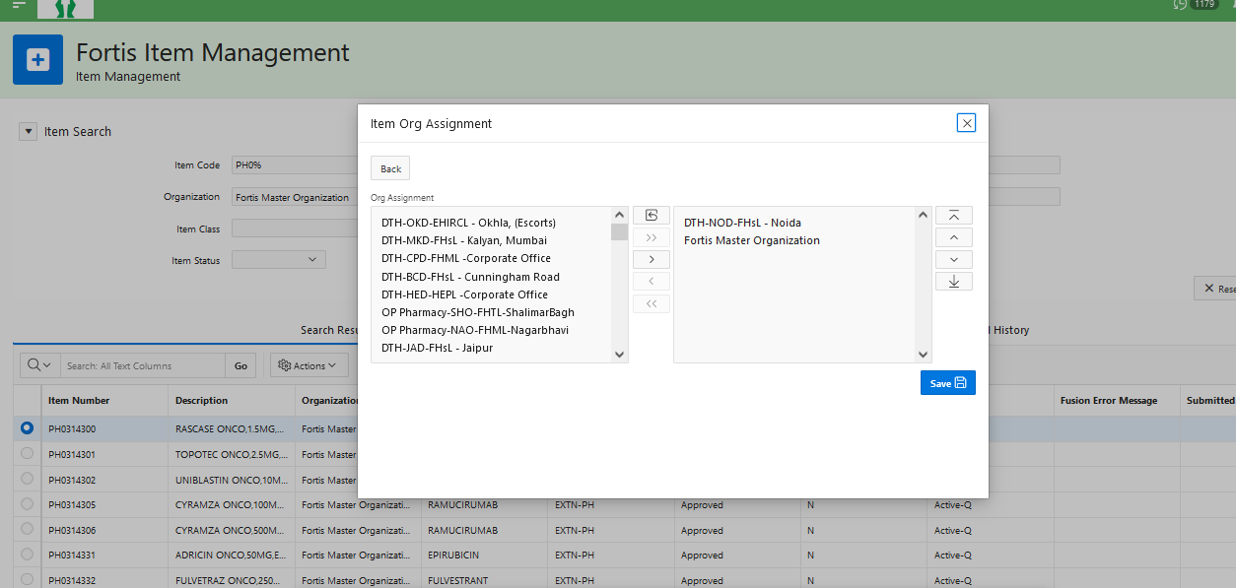

* Following “Action History” page comes up from the icon available at top right-hand side of the Home page. This page displays all the notifications which has been actioned by the current logged in user in the descending order.

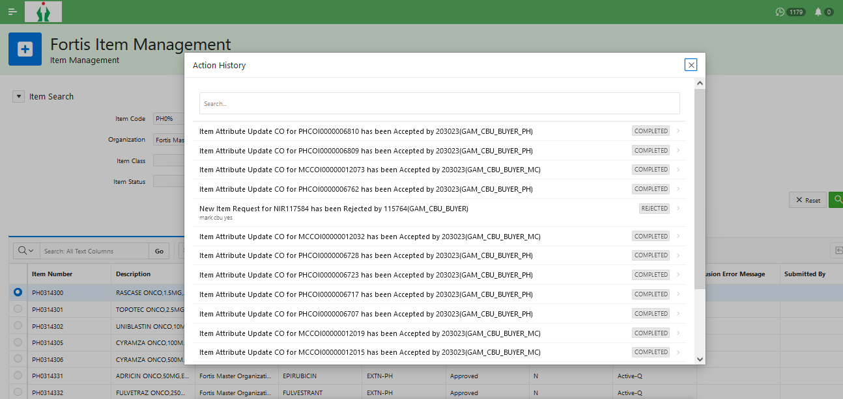

* Following “Workflow Notifications” page shows the pending workflow notifications with the current logged in user.

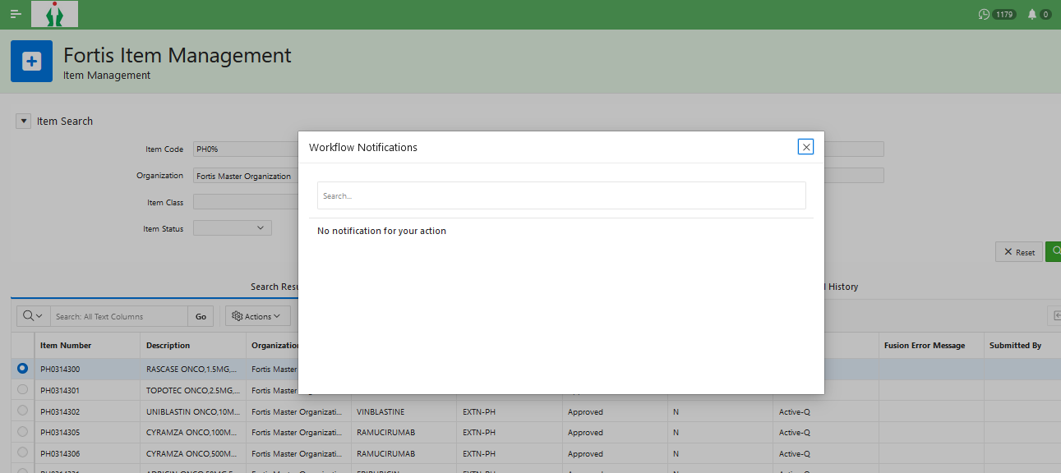

## Additional Extension Validations & Deriving Logics

| S. No | Validation | Derivation Logic / Explanation | Remarks |
| --- | --- | --- | --- |
| 1. | Cross entry of irrelevant attributes | Only the relevant attributes of an item must be visible for entry on the attribute update / assignment pages. E.g., if the item is of stockable nature, then planning attributes should not be available for input. Further elaboration:   * PH/MC Item Type Stockable: Planning attributes and consigned flag should not be available for editing. Consigned flag must be No. * PH/MC Item Type ROL (Re-order level planning): Planning attributes should be available for editing. Consigned flag should not be available for editing and must be No.. * PH/MC Item Type Consigned: Consigned flag should not be available for editing and must be Yes. Planning attributes should not be available for editing. * NM / SV: Planning attributes and consigned flag should not be visible for editing. |  |
| 2 | Central Parameters update | Update of Central parameters (attributes placed under the Central Parameters section of the item assignment & update pages) will be always done at the FMO org level. |  |
| 3. | Item Org Assignment transformation | Org structure- Each BU will have the following IOs:   * DTH Org- for the purpose of assigning stocked, planned and consigned PH/MC items which get transferred to HIS (DTH- Direct to HIS). NM inventory expense items will also get assigned to this org. * NM Org- for the purpose of assigning NM items- both inventory exp and exp. * SV Org- for the purpose of assigning Service items * OP Pharmacy- for the purpose of assigning stocked PH/MC items. This org will be selectively available in the BUs on a need basis. * Count Correction- for the purpose of assigning all PH/MC items. Used for counting process. * Count Correction OP Pharmacy- for the purpose of assigning all PH/MC items. Used for counting process and will be available only with a OP Pharmacy IO. * Validation org- for the purpose of assigning all items irrespective of any property.   Depending upon the item class, below item org assignment transformation logics will be applied:   * PH / MC item class- In addition to a DTH org assignment, Count Correction org and Validation Org will be assigned to the item under the same BU as of DTH org.   + Applicable to all the PH/MC items   + Item will be assigned to both Count Correction and OP Pharmacy Count Correction if there is a OP Pharmacy defined in the BU and item is assigned to that OP Pharmacy org as well.   + Attributes of the item assignment to Count Correction and Validation org will be kept as like the respective DTH org. * NM item class, Inventory type as Inventory expense- In addition to the NM org assignment, DTH and Validation Org will be assigned to the item under the same BU as of NM org.   + Attributes of the item assignment to Validation org will be kept as like the respective NM org. * NM item class, Inventory type as Expense- In addition to the NM org assignment, Validation Org will be assigned to the item under the same BU as of NM org.   + Attributes of the item assignment to Validation org will be kept as like the respective NM org. * SV item class- In addition to the SV org assignment, Validation Org will be assigned to the item under the same BU as of SV org.   + Attributes of the item assignment to Validation org will be kept as like the respective SV org. * PH / MC items in OP pharmacy- In addition to assigning the items in the OP pharmacy IO, Count Correction org and Validation Org of OP pharmacy will also be assigned under the same BU as of the OP pharmacy IO. |  |
| 4. | Item price consistency | Item price changed in any one of the IOs will be replicated in the other IOs of the BU in which the item price has been changed.   * Item price will be updated first in the DTH / NM / SV org of the item in a BU. * Post approval of the item update request, the item price should be updated on all the IOs in the BU of updated item’s IO to which the item is assigned. E.g., if the price is updated in DTH Shalimar Bagh Org and the item is assigned to DTH, Count Correction and Validation orgs in Shalimar Bagh BU, then the item price update should be synced to Count Correction and Validation orgs for Shalimar Bagh BU as well. |  |
| 5 | Item price change propagation | Item price changed for a CBU controlled item will be propagated to all the IOs, whether initiated by the unit user or CBU user. |  |
| 7 | Submission of item price update request | An update on the item (price/assignment/inventory) will be allowed only if there is no existing update request pending for the item. This will prevent any conflicting updates on the item. |  |
| 8 | Availability of actions on the items | All actions on the items under search results will be available based on access provided to the users in Oracle PDH.  For e.g.:   * User A searches for an item X and finds that it is assigned to N number of IOs. * User A can edit an item X only in those organizations for which he/she is granted access in. * Access to edit the item will be given at the item class level. |  |

## Technical flow

Following is the complete technical flow for this integration design:

**Server details:**

|  |  |  |  |  |
| --- | --- | --- | --- | --- |
| **Server** | **Host name** | **Port** | **Service Name** | **Username** |
| Oracle PaaS DB | 140.238.225.129 | 1521 | PRODPDB1.fhpubsn.fhvcn.oraclevcn.com | XXFH & XXFH_RO |

# Data FIELD Mapping

NA

## File format

NA

## Frequency

The GRN Put away integration is scheduled to run every 30 minutes.

## Security and Access

Item Management application can be accessed via Fusion application, any of the following custom roles are required to access it, however the functionality access within bolt-on shall be different as per the role:

|  |  |  |
| --- | --- | --- |
| SI No | Role Code | Meaning |
| 1 | JOB_INVENTORY_MDM | This is a super user role for Item bolt-on. A user with this role is a Central user who can execute all the steps. |
| 2 | JOB_UNIT_ICA | This role is for users who can create & do organization assignment |
| 3 | JOB_UNIT_IU | This role is for users who can just do Attribute update. |
| 4 | JOB_UNIT_PU | This role is for users who can do Item price update. |
| 5 | JOB_ITEM_VIEW | This role is for users who should not be able to execute any transaction on an Item. Basically, this role is assigned to users who are just approvers to approve various item related requests within Item bolt-on application. |

## Apex application Authentication scheme

Item management application’s authentication is validated using the following authentication scheme defined within Oracle APEX. This authentication scheme basically invokes a procedure: XXFH_CUSTOM_AUTH.ITEM_AUTHENTICATE_USER by passing the entered username & password. This procedure validates this credential against the details present in XXFH_PER_USERS table and allow successful login to the application if the credentials & access are correct. Otherwise, user get “invalid credential” error.

XXFH_PER_USERS.ITEM_APP_ACCESS_FLAG is set to Y if the given user has any of the 5 roles assigned for Item (defined under 6.3 section). This flag is also validated within this procedure to check if the given user should be able to login to the Item management application or not.

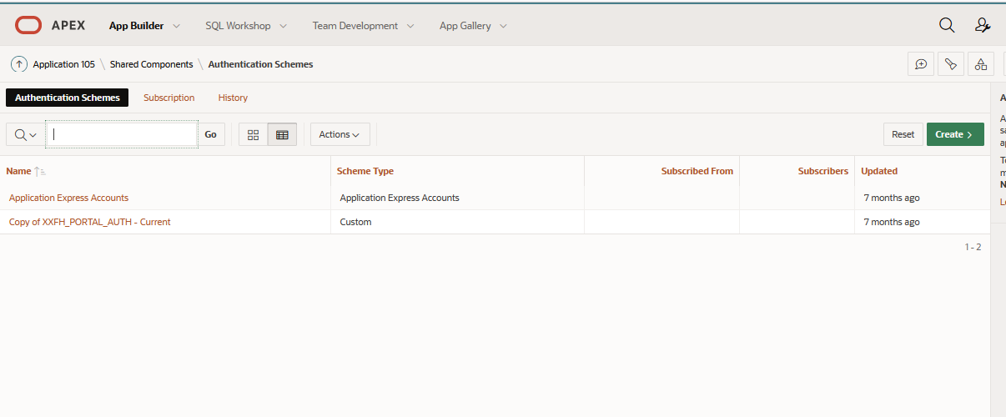

## Apex application List of Values

Following LOVs have been defined for Item management application which are being used within the pages:

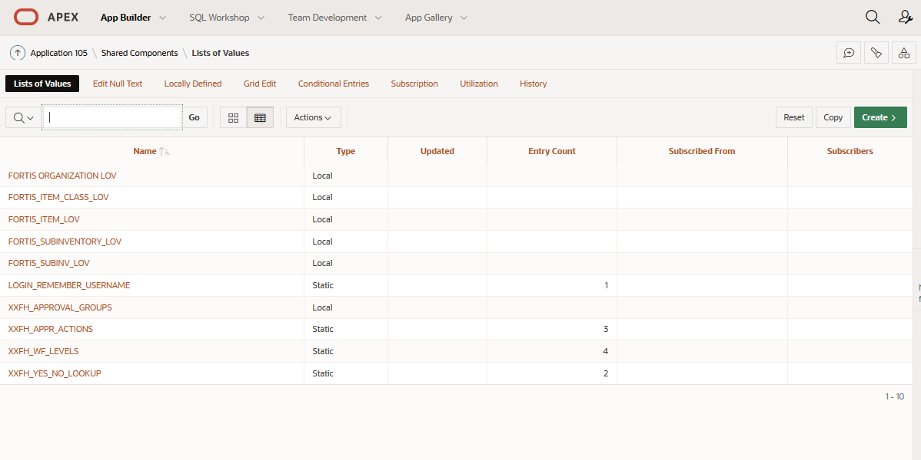

## Apex application – Approval Workflow Specification

Item management application uses the following custom approval workflows which have been designed within Oracle APEX using plugin application: Flows for Apex.

| Application Name | Flow Name | Description |
| --- | --- | --- |
| Flows for APEX | Fortis New Item Request Approval (ver 0) | This approval workflow is designed for New Item requests. |
| Fortis Item Attribute Update Approval (ver 0) | This workflow process is for Item attribute update requests. |
| Fortis Item Org Assignment Approval (ver 1) | This workflow process is for Item Organization assignment requests. |
| Fortis Item Price Update Approval (ver 0) | This workflow process is for Item price update requests. |

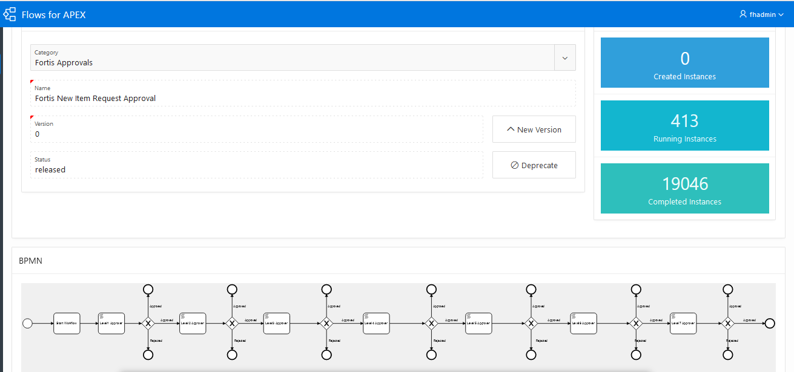

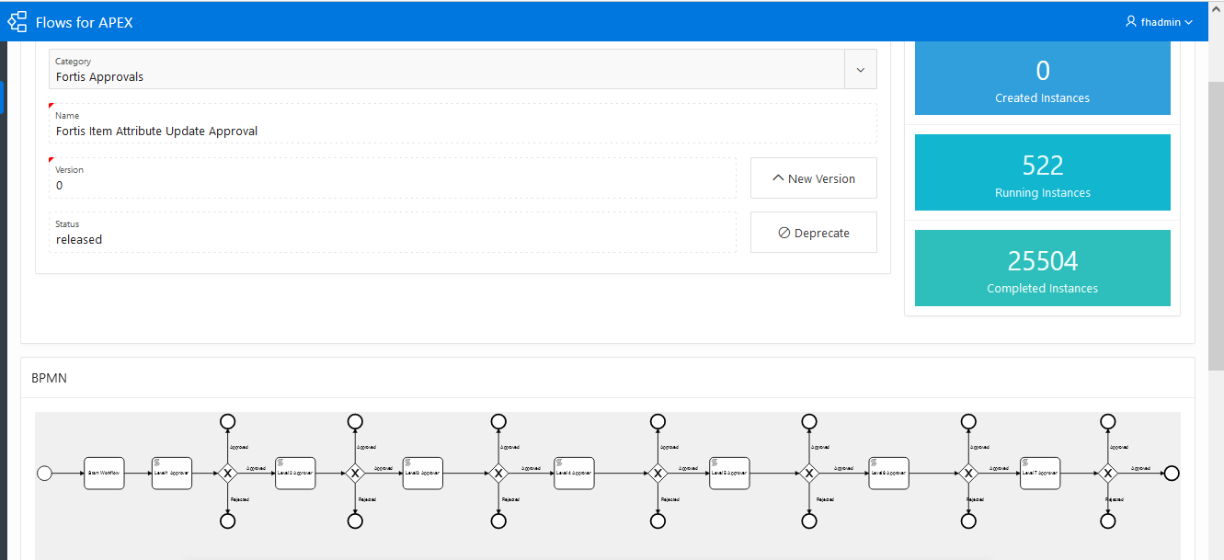

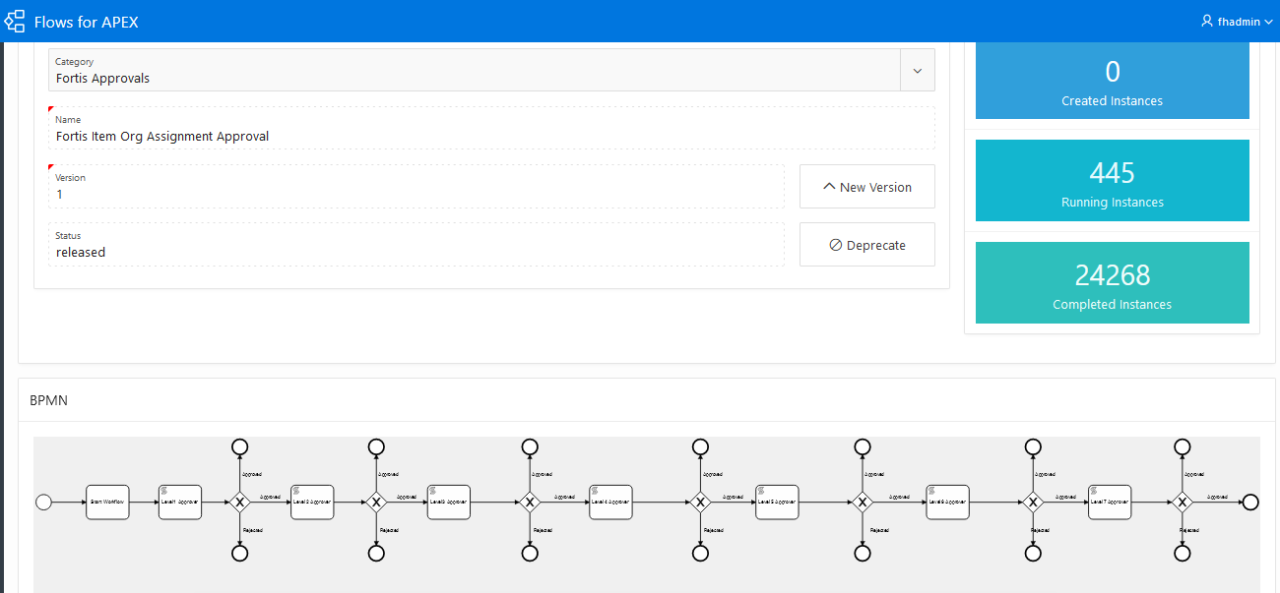

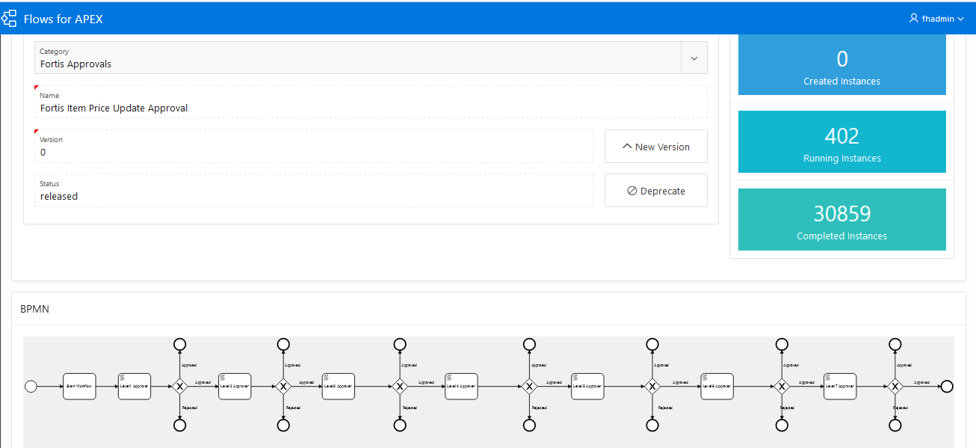

# Exception handling

There can be various scenarios for an error to occur. This section defines those error scenarios, and the exception handling has been done to notify and act accordingly.

## Scenarios

In a tabular format give list of scenarios and exception handling

* If any of the step or node fails within the OIC integration, Global Fault section is configured within this OIC integration to send an OIC error notification with relevant details.
* The email id has been stored in OIC Lookup: Fortis_FaultNotification_EmailAddress_Lookup against the given OIC integration name.
* It also sends a notification every 10 minutes with the details of the GRN which have been processed in the given run. This notification also acts as a confirmation that the integration has been running fine.

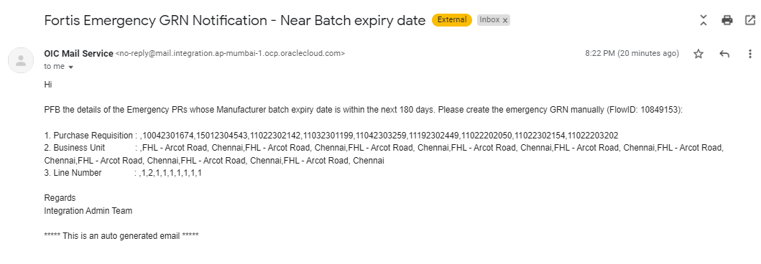

# Assumptions / Considerations

The Proposed Solution will have the following technical considerations.

In the future, if any product bug arises in functionality then this process needs to be revisited after the bug is fixed.

# Open and Closed Issues

## Open Issues

| ID | Issue | Resolution | Responsibility | Target Date | Impact Date |
| --- | --- | --- | --- | --- | --- |
|  |  |  |  |  |  |
|  |  |  |  |  |  |
|  |  |  |  |  |  |
|  |  |  |  |  |  |

## Closed Issues

| ID | Issue | Resolution | Responsibility | Target Date | Impact Date |
| --- | --- | --- | --- | --- | --- |
|  |  |  |  |  |  |
|  |  |  |  |  |  |
|  |  |  |  |  |  |
|  |  |  |  |  |  |